1:.search is not working Fixed

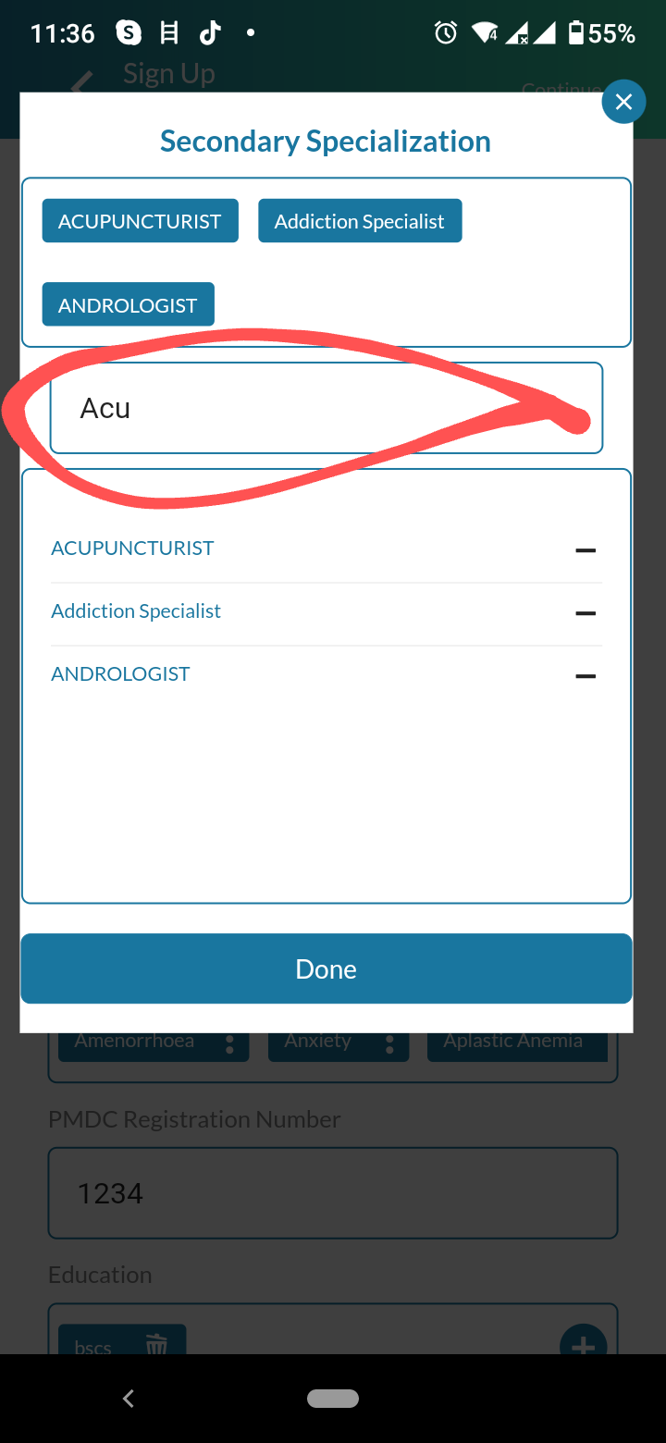

In service offer , search is not working Fixed

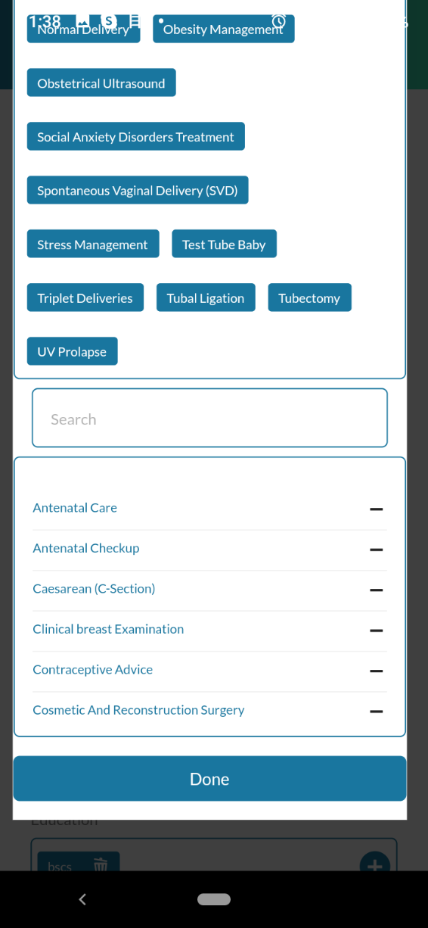

In condition treated , search is not working Fixed

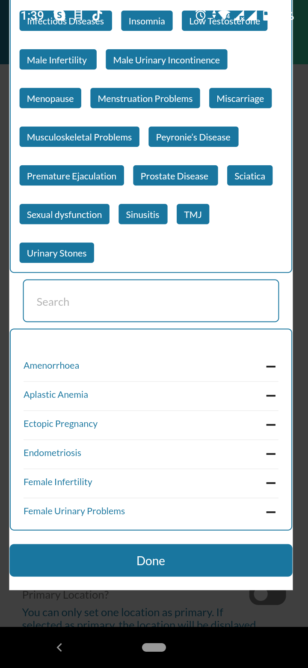

2: Dr iqra is still hard coded Fixed

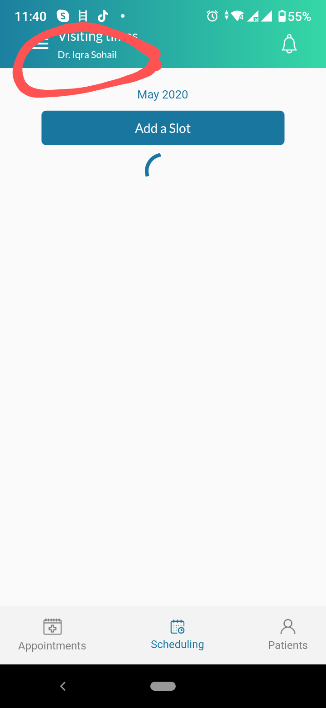

3: Drop-down view is disturbed

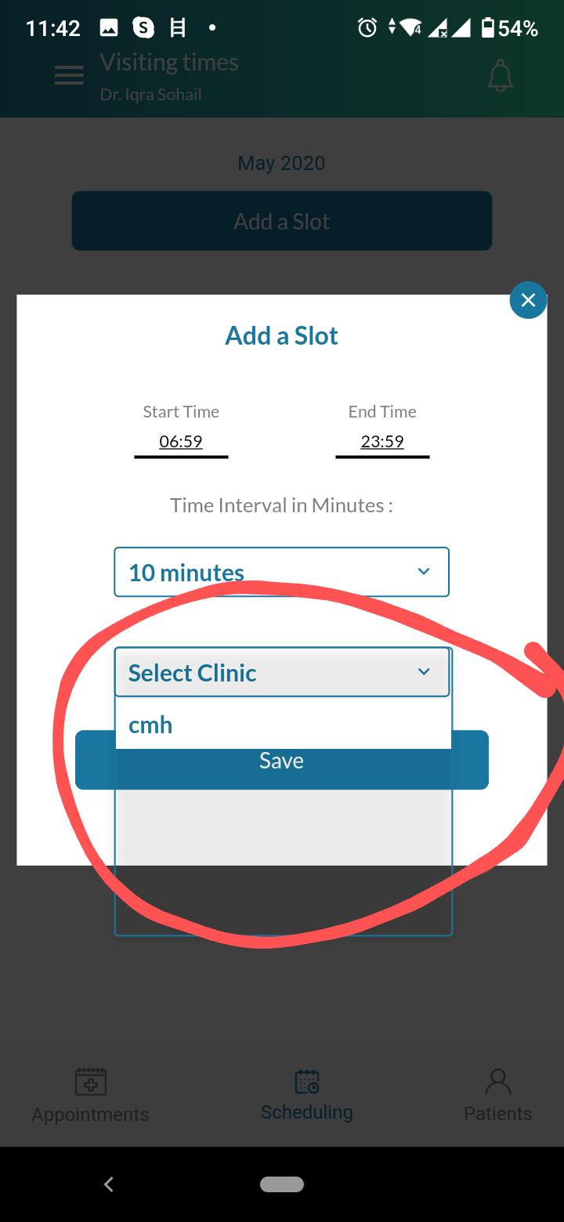

4: please add translation both Farsi and pashto

5: When I add slot for clinic, it doesn't not show confirmation regarding adding slots and when I again add slot for the same clinic, it gives error server response

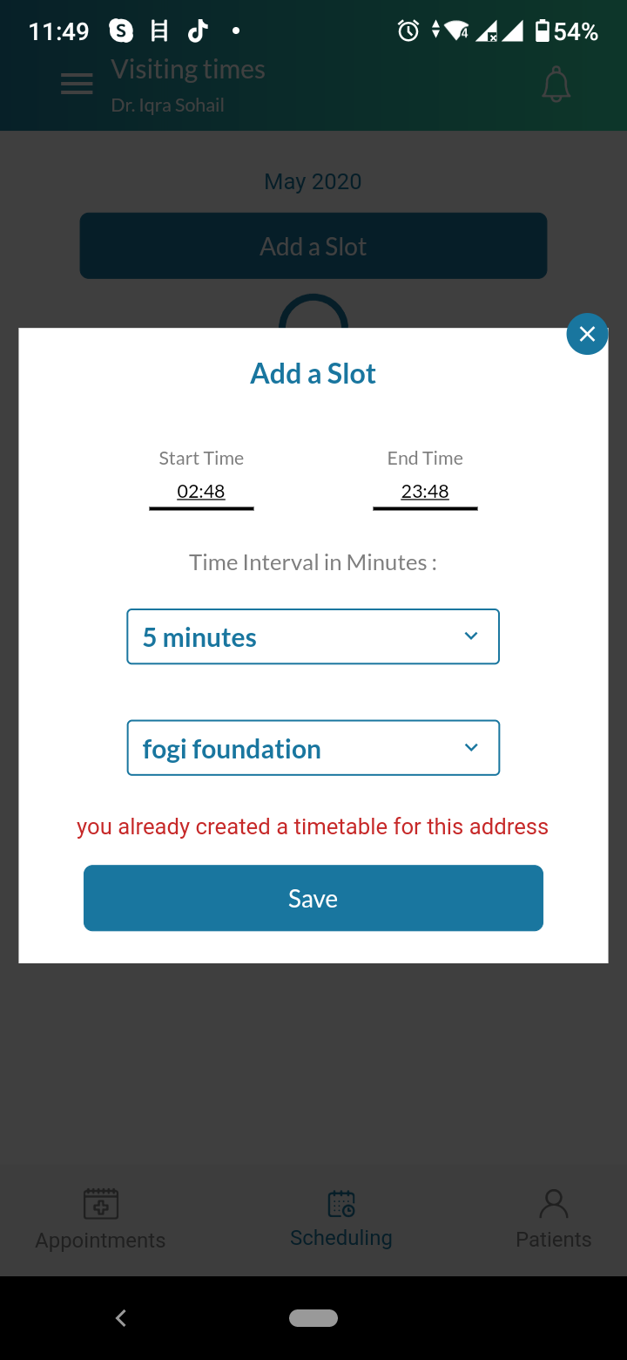

6: When I tap on accept appointment, it gives error api dev

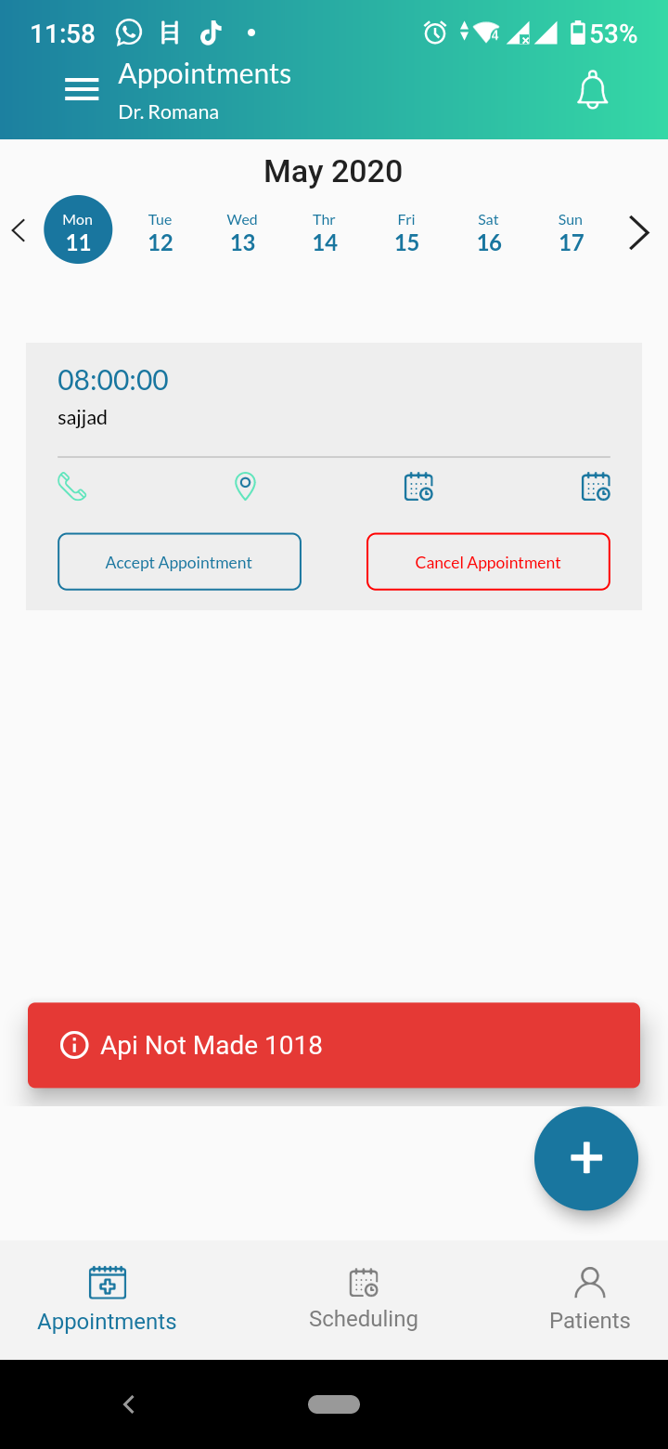

7: Doctor has cancelled sajjad appointment then why in patient panel, this appointment is showing to patient?? It should be cancel and patient should know about this api dev

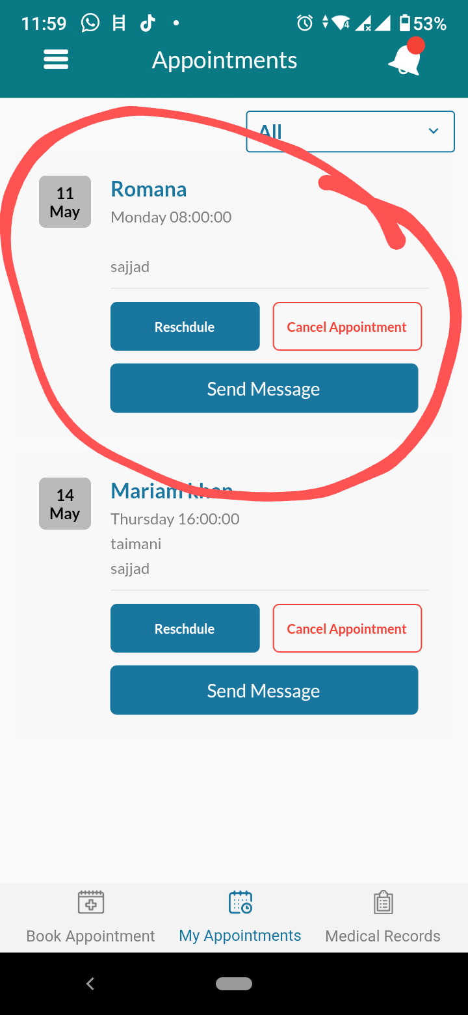

8: Tapping on practice profile, it should must open a form but now form is missing. Add that form Which form?